# A Comprehensive Guide to The Mathematics of Quantum Mechanics

We will explore the fundamental mathematical concepts and properties needed to understand Quantum Mechanics. These concepts will be imperative in understanding the inner working of**Quantum Finance.**

# Table of Contents

1. **Vector Space**  
   - 1.1 Vector Addition  
   - 1.2 Scalar Multiplication
2. **Complex Numbers**  
   - 2.1 Definition of an Imaginary Number  
   - 2.2 Definition of a Complex Number  
   - 2.3 Euler’s Formula for Complex Numbers
3. **Complex Conjugate**  
   - 3.1 Complex Conjugate Addition  
   - 3.2 Complex Conjugate Multiplication
4. **Hilbert Space**  
   - 4.1 Properties of Hilbert Spaces  
   - 4.2 Types of Hilbert Spaces
5. **Dirac Notation**  
   - 5.1 First Postulate of Quantum Mechanics  
   - 5.2 Notation  
   - 5.3 Properties of Dirac Notation  
   - 5.4 Braket Properties
6. **Operators**  
   - 6.1 Vector Space with Finite Dimensions  
   - 6.2 Function Space  
   - 6.3 Properties of Operators
7. **Types of Operators**  
   - 7.1 Inverse Operators  
   - 7.2 Hermitian Operators  
   - 7.3 Unitary Operatory  
   - 7.4 Projection Operator
8. **Commutators**  
   - 8.1 Anti-Commutator  
   - 8.2 Properties of Commutators
9. **Brief Introduction to Eigenvalues and Eigenvectors**

# 1. Vector Space

A vector space is a space in which a set of vectors and associated scalers have certain properties, such as vector addition and scalar multiplication.

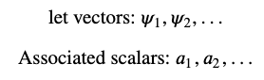

# 1.1 Vector Addition

Properties of Vector Addition under a Vector Space.

## **Vector Space Must be Closed under Addition:**

The addition of two vectors must be within the vector space if the two vectors exist in the space.



## **Vector Addition Must be Commutative:**

Commutative law in vector addition.



## **Vector Addition Must be Associative:**

Associative law in vector addition.



## **Zero Vectors:**

for each 𝜓𝑖 there is a vector **0** such that:

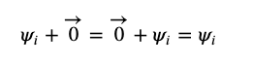

## **Inverse Property:**

for each 𝜓𝑖 there is a vector −𝜓𝑖 such that:



# 1.2 Scalar Multiplication

Scalar multiplication is when we multiply a **vector** by a **scalar**.

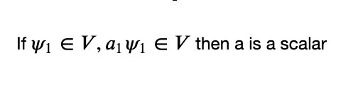

## Distributive Property:

We can distribute the scalars amongst each vector and distribute a scalar to multiple vectors.

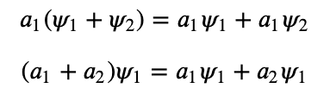

## Associative Property:

There is no difference in order when it comes to scalar multiplication.



## Identity and Zero Scalar Properties:

For every:



there exists an **I (Identity Matrix)**and a **0 (Zero Vector)**such that:

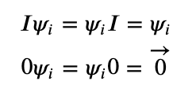

# 2. Complex Numbers

In order to understand the particular vector space used in quantum mechanics, namely the Hilbert Space, we need to have a good understanding of complex numbers and the complex plane first.

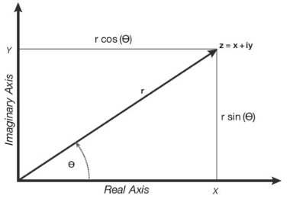

Complex numbers can be thought of as a way of re-expressing vector spaces by substituting the classical Cartesian axis of x and y with the Real Axis (Re), that contains all real numbers on the horizontal axis and the Imaginary Axis (Im) that contains all imaginary numbers on the vertical axis.

# 2.1 Definition of an Imaginary Number

An imaginary number, expressed as 𝑖 is a mathematical construct that when squared yields −1, therefore:

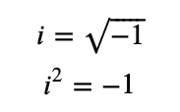

# 2.2 Definition of a Complex Number

A complex number is a number that is formed by a combination of a **Real Part** and an **Imaginary Part**. These numbers are usually denoted with the letter 𝑧.

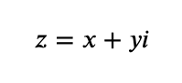

Where,

𝑥 is the real part

𝑦 is the imaginary part, which is the number that is scaling the imaginary number

𝑦𝑖 is an imaginary number

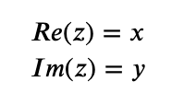

# 2.3 Euler’s Formula for Complex Numbers

The vector in polar coordinate form takes the value:

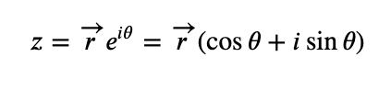

This comes from **Euler’s Formula** which is a special case of the above where the r-component is 1:

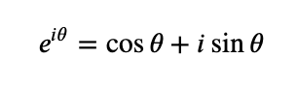

Which means we can restate our complex number as:

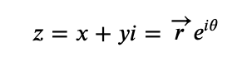

# 3. Complex Conjugates

The **Complex Conjugate** of a complex number 𝑧, denoted as 𝑧∗ is obtained by reversing the sign of the imaginary part.

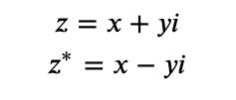

If we graph this out, we can imagine the complex conjugate of a complex number as being its mirror opposite.

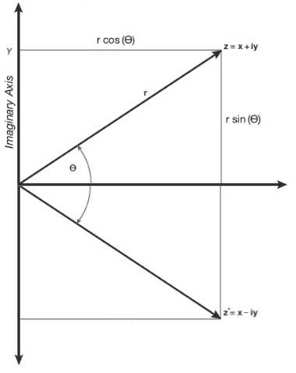

# 3.1 Complex Conjugate Addition

Adding a complex number and its complex conjugate **always** gives us a **real number**

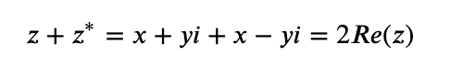

# 3.2 Complex Conjugate Multiplication

Multiplying a complex number and its complex conjugate **always** gives us a **positive real result**



# 4. Hilbert Space

The **Hilbert Space**is a special kind of**vector space** with the same general properties of the **traditional vector space plus additional properties.**

# 4.1 Properties of Hilbert Spaces

* **Linear Vector Space:** A Hilbert space is therefore a linear vector space
* **Has an Inner Product Operation:** that satisfies certain conditions. The Inner Product (that needs two input vectors and outputs a scalar) is defined as:

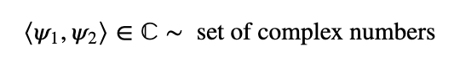

* **Conjugate Symmetry**: The **inner products** of two vectors is equal to the inner product of the complex conjugate of the vectors in reverse order. (NOT COMMUTATIVE)

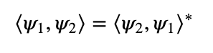

* **Linear w.r.t. the Second Vector:**A scalar can be distributed amongst the pairs of vectors when the **second argument of the inner product is a sum**

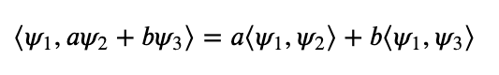

* **Anti-linear w.r.t. the First Vector:**A scalar can be distributed amongst the pairs of vectors as a complex conjugate of the scaler when the **first argument of the inner product is a sum**

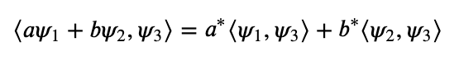

* **Non-Negativity of Inner Product of Same Vector (Positive Definiteness):**The function/vector is square integrable

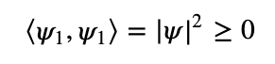

* **Distance Formula to Describe:** how close two vectors are to each other:



## Separability

**Hilbert Spaces are Separable, therefore, contain a Countable, Dense, subset:**

* **Countable:** as we can find a closed set of integers to express the set.
* **Dense:** any real number is either rational and if not we can find a rational number that is arbitrarily close to the irrational real number (truncating decimals instead of letting them go to infinity) (where closeness can be defined by the distance formula above)
* **Separate:** therefore they are separable

## Completeness

**Hilbert Spaces are Complete:** meaning there are no gaps.

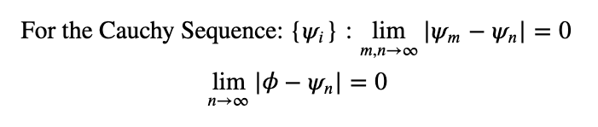

Where,

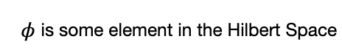

# 4.2 Types of Hilbert Spaces

# 4.2.1 Finite-Dimensional Hilbert Space:

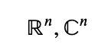

Where for each sets there are **n**well-defined basis vectors.

## **a. Inner Product on the Real Line:**



**Defining the Vectors:**

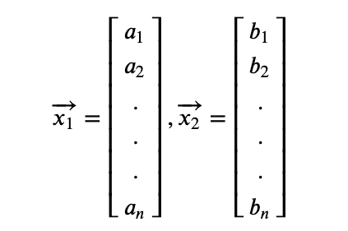

**Defining the Inner Product:**

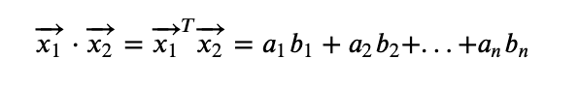

## **b. Inner Product on the Complex Line:**



**Defining the Vectors:**

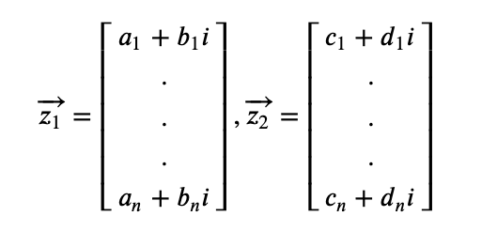

**Defining the Inner Product:**

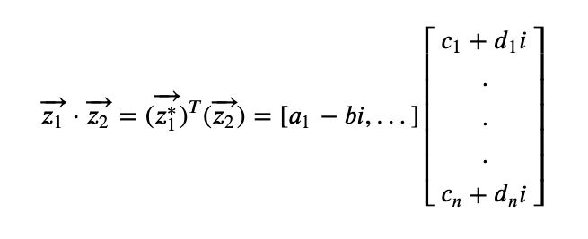

# 4.2.2 Infinite-Dimensional Hilbert Space

Like the vector space of complex-valued functions, with inner product, with the functions being **Square Integrable Functions**:

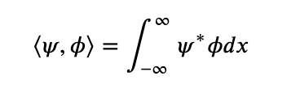

**Square Integrable Functions:**

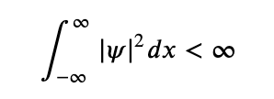

This is important since if we take the inner product of two square integrable functions then because the **integral is finite**, then the inner product as a result will exist and be **finite**.

**Normalization:**

In quantum mechanics, the square integrable functions are also normalized:

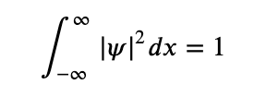

# 5. Dirac Notation

Dirac’s Notation is a mathematical formalism that helps explain the meaning of vectors and functions in a Hilbert Space.

# 5.1 First Postulate of Quantum Mechanics

The **physical** state of the system is represented by a **vector** in the Hilbert space.

## **Wave Function**

A wave function:



is related to the **probability** of finding a particle at



at a time 𝑡.

**The wave function ψ:**represents the state or condition of the system and therefore can represent **vectors in a Hilbert space** which consists of the **set of normalized square integrable functions**

## Spin State of a Particle

Within an orbital, an electron can be either **spin up** or **spin down**, where:

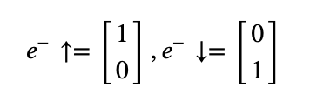

Which are vectors in a Hilbert space.

# 5.2 Notation

Dirac Notation is used to express mathematical constructs in quantum mechanics such as vectors, inner products and operators.

# a. Kets — Vectors in Dirac Notation

Vectors are represented by Kets:

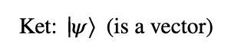

We can use an example to illustrate Kets.

## Representing the Wave Function and Spin States as Kets:

1. **The Wave Function:**

can be represented with its Ket form by remembering that it is a function of the vector r

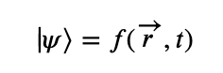

**2. The Spin State:**

The spin state of a particle is already a vector and therefore its Ket form is described as: (spin up)

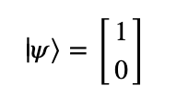

# b. Bras — Conjugate of the Ket Vector

## Bras for Vectors:

**a. Spin Up Vector:**The **Bra would be the complex conjugate of the transpose of the vector or ket**.

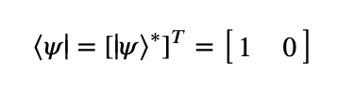

**b. Bras for Functions:**

Using our function above, its bra would be the **complex conjugate** of the function.

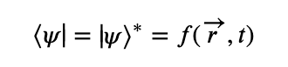

# c. Braket — Inner Product in Hilbert Space

The Braket is essentially the inner product of a vector/functions and the complex conjugate of the same or another vector/function.

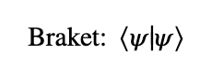

## - Brakets for Vectors:

Let’s use the example of the spin up vector.

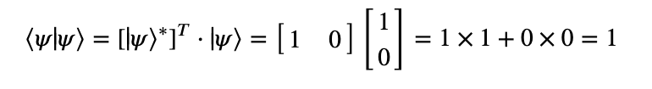

## - Brakets for Functions:

Using our function:

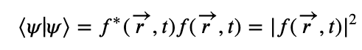

# 5.3 Properties of Dirac Notation

## **a. Every Ket has a Bra:**

which is the same as saying that every complex number has a complex conjugate.

## **b. Constant Multiple Property**

Taking a constant multiple out of a ket yields the same constant, taking it put of a bra yields the complex conjugate of the constant.

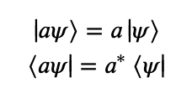

## **Examples:**

* **Ket:**

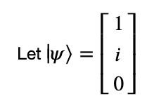

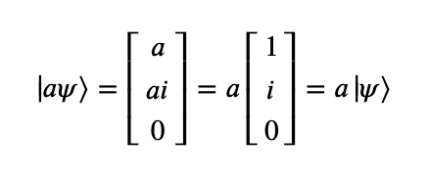

* **Bra:**

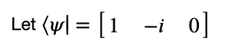



# 5.3 Braket Properties

Brakets have the same properties of the inner product in a Hilbert Space:

* **Conjugate Symmetry:**

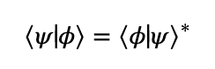

* **Linearity w.r.t. the second vector:**

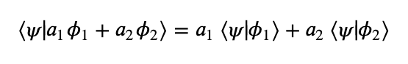

* **Anti-linearity w.r.t. the first vector:**

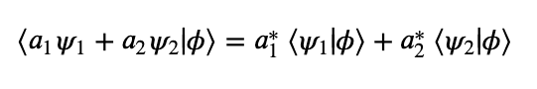

* **Norm is positive definite:**

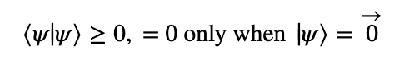

## a. Triangle Inequality

Means that the**magnitude of the sum of the two vectors is less than or equal to the sum of the magnitudes of the individual vectors** (equivalent to saying that the length of the sides of a triangle is greater than the length pf the first side).

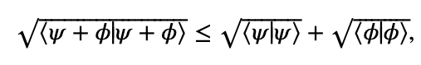



## b. Schwarz Inequality

The squared of the inner product of two vectors is less than or equal to the product of the norms of the individual vectors.

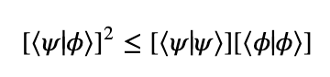

## c. Orthogonality

Two vectors are **Orthogonal** if their inner product is zero:

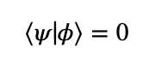

In the Real Space it means that the vectors form a 90 degree angle and are perpendicular to each other.

## **d. Orthonormality**

If they are orthogonal and their magnitudes are equal to one. The vectors are both normalizes (like the i and j vectors in the Cartesian plane).

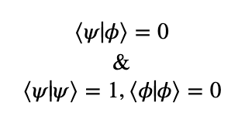

# 6. Operators

Operators can be thought of as **transformations** that take an input Ket or Bra and transforms them into another Ket or Bra. Certain types of operators also represent physical quantities.

As a **ket** can be represented by a **column vector** and a **bra** as a **row vector**:

* Operating on a **Ket** has to be done from the **left**
* Operating on a **Bra** has to be done from the **right**

This is given due to the fact that operators can be represented as matrices and if we do not operate in this way, matrix multiplication would not be valid.

**Operators on Kets:**

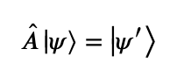

**Operators on Bras:**

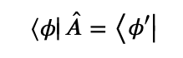

where A hat is an **operator**.

# 6.1 Vector Space with Finite Dimensions

Let our operator A hat be a square matrix:

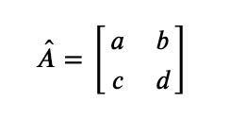

## Ket Representation:

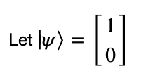

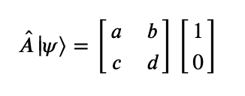

## **Bra Representation:**

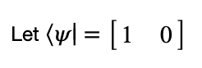

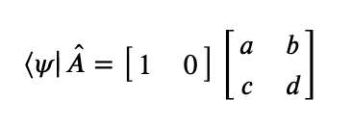

# 6.2 Function Space

In function space, operators are not usually represented by matrices, and may come in the form of **derivatives**.

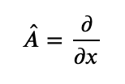

# 6.3 Properties of Operators

## **Operators Do Not Commute:**

Order matters, just like matrices do not commute

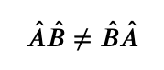

## **Associative Property:**

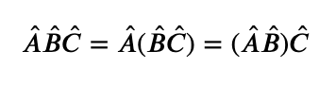

## **Power Property:**

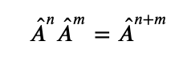

## **Operators inside Brakets:**

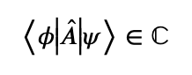

Given that

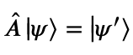

which is another vector, therefore:

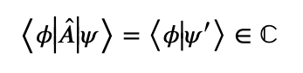

## Linear Operators:

a linear operator follows the following rules

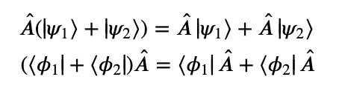

and

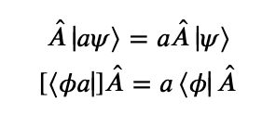

## **Expectation Value of the Operator:**

with respect to a state |𝜓⟩ Since some operators represent physical observables, we can express the expectation value of an operator as follows:

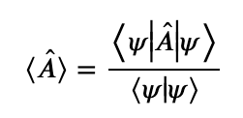

## **Outer Product:**

The **outer product** is a linear operator

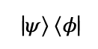

Example:

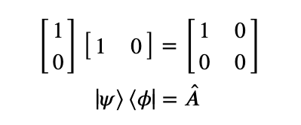

# 7. Types of Operators

# 7.1 Inverse Operators

Suppose we have a linear operator 𝐴̂. Its inverse will be:



such that:

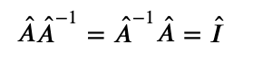

Where I hat is the **Identity Operator**(that returns the given ket or bra when applied to it).

Inverse operators are useful in expressing divisions such as:

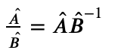

## Properties:

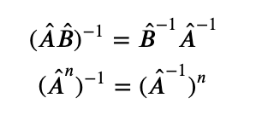

# 7.2 Hermitian Operators

In order to understand Hermitian Operators, we must first understand the concept of Hermitian Adjoints and Conjugates.

## a. Hermitian Adjoint/Conjugate

* **For a Scalar a:**the Hermitian conjugate is simply the complex conjugate of the scalar, where the Hermitian conjugate is denoted by the dagger symbol

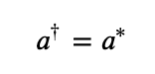

* **For a Ket:**  
  the Hermitian conjugate is the corresponding bra

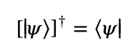

* **For a Bra:**the Hermitian conjugate is the corresponding ket

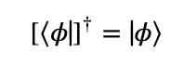

* **For an Operator:**The Hermitian conjugate is such that the inner product **switches the operator from the ket to the bra** (as it is the complex conjugate and the bra is the complex conjugate of the ket)

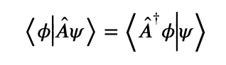

or

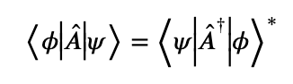

## Properties of the Hermitian Conjugate

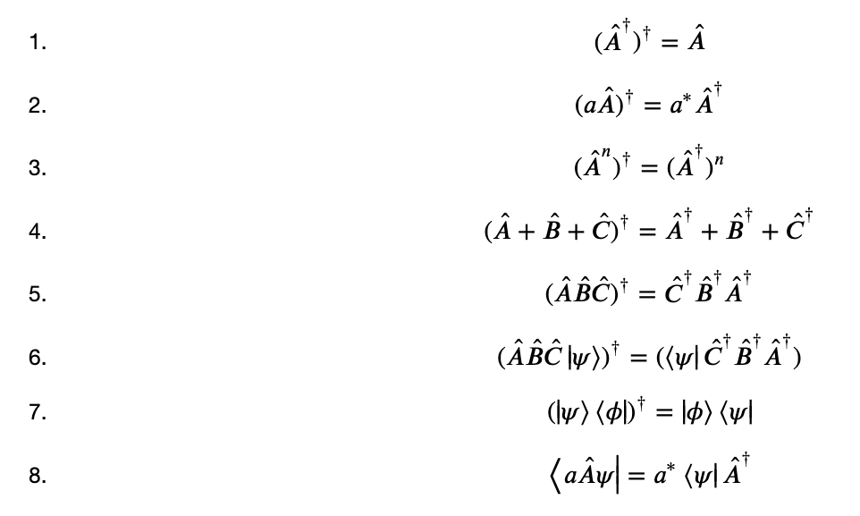

## b. Hermitian Operator

* **Hermitian Operator:**A hat is a Hermitian Operator if it is equal to its **Hermitian Conjugate**

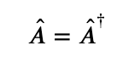

Example:

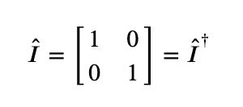

* **Anti-Hermitian Operator:**  
  is the **negative** of its Hermitian conjugate

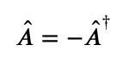

Example:

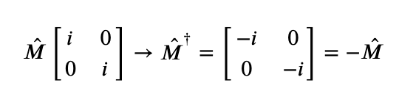

# 7.3 Unitary Operator

An operator U hat is **Unitary** if its Hermitian equals its inverse

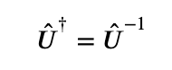

## **Property:**

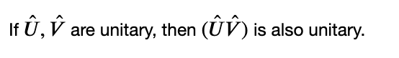

# 7.4 Projection Operator

A projection operator P hat satisfies two conditions, that it is **Hermitian** and that it is **equal to its own square**.

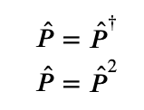

## Identity Operator as a Projection

The identity operator is projecting the vector onto itself.

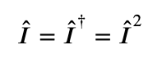

## Properties

* **Commutative Property:**

if two projection operators

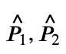

commute:

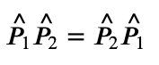

then:

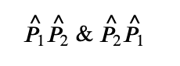

are projection operators.

* **Orthogonality:**

if:



are orthogonal projection operators then:

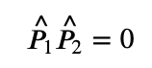

* **Sum of Projection Operators:** The sum of projection operators can be a projection operator if and only if all the projection operators in the sum are **mutually orthogonal**, meaning they are all orthogonal to each other.

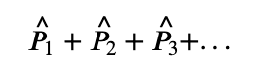

# 8. Commutators

Let:



be two operators, then their **commutator**is given by:

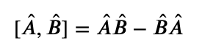

This describes the extent to which A hat and B hat commute, meaning the extent they are commutative.

Therefore, if they **commute**, the **commutator is zero**

# 8.1 Anti-Commutators

describe the extent to which A hat and B hat are **anti-commutative:**



With their Anti-Commutators being:

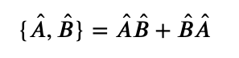

# 8.2 Properties of Commutators

## 1. The Commutator of an Operator with itself

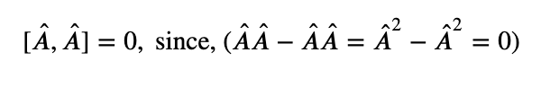

## 2. Anti-Symmetry

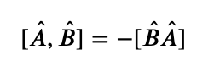

## 3. Linearity

commutator is a linear operation

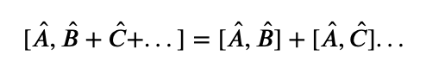

## 4. Hermitian Conjugate

The Hermitian Conjugate of A hat and B hat is the **Hermitian Conjugate of B hat and A hat**. This is given that the operators are matrices. In general the commutator itself is a matrix.

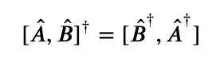

## 5. Distributivity

Simple Case:

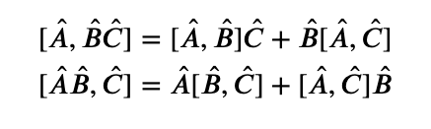

## 6. Jacobi Identity

The sum of large commutators which each involves different small commutators inside of the main commutators equal to zero.

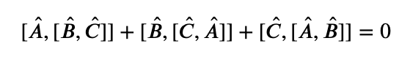

## 7. **Operators Commute with Scalars**

operators and scalars commute

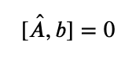

with b being a scalar

## 8. **The Commutator of Two Hermitian Operators is Anti-Hermitian**

If A hat and B hat are Hermitian Operators, then:

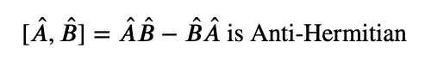

## 9. **The Anti-Commutator of two Hermitian Operators is Hermitian**

If A hat and B hat are Hermitian Operators, then:

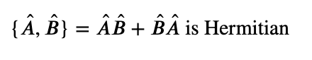

# 9. Brief Introduction to Eigenvalues and Eigenvectors

Suppose A hat is an operator. The eigenvalue of this operator is a complex number 𝜆 which satisfies:

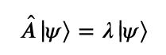

which, in its linear algebra notation is similar to

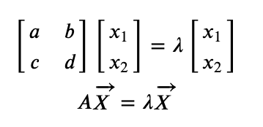



This Article is published on [**The Quant Journey**](https://medium.com/the-quant-journey), an initiative started to take the readers along side this journey towards learning about quantitative finance topics.

Check out our **Instagram** Page: [**The Quant Journey**](https://www.instagram.com/thequantjourney/?hl=en)



1

## [**More from The Quant Journey**](https://medium.com/the-quant-journey?source=post_page-----67a3e0b11d17-----------------------------------)

Following

This is a repository of information regarding everything quantitative. I am building my knowledge as I go, therefore this is a journey for both me as a contributor and you as a reader as we venture in to the world of mathematics, programming, statistics, finance and business.

Andrea Chello

[Andrea Chello](https://medium.com/@chelloandrea?source=post_page-----67a3e0b11d17----0-------------------------------)

[·3 days ago](https://medium.com/the-quant-journey/five-factor-asset-pricing-model-analysis-b8b0463c8449?source=post_page-----67a3e0b11d17----0-------------------------------)

## [Five-Factor Asset Pricing Model Analysis](https://medium.com/the-quant-journey/five-factor-asset-pricing-model-analysis-b8b0463c8449?source=post_page-----67a3e0b11d17----0-------------------------------)

[Finance](https://medium.com/tag/finance?source=post_page-----67a3e0b11d17---------------finance--------------------)

[4 min read](https://medium.com/the-quant-journey/five-factor-asset-pricing-model-analysis-b8b0463c8449?source=post_page-----67a3e0b11d17----0-------------------------------)

[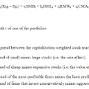](https://medium.com/the-quant-journey/five-factor-asset-pricing-model-analysis-b8b0463c8449?source=post_page-----67a3e0b11d17----0-------------------------------)

Post a quick thought or a long story. It's easy and free.

[Write with the app](https://rsci.app.link/?%24canonical_url=https%3A%2F%2Fmedium.com%2Fnew-story&source=post_page_footer_cta_write----------------------------------------)

Andrea Chello

[Andrea Chello](https://medium.com/@chelloandrea?source=post_page-----67a3e0b11d17----1-------------------------------)

[·4 days ago](https://medium.com/the-quant-journey/effects-of-changes-in-oil-rents-and-broad-money-on-an-as-ad-model-from-1970-to-2007-4e5320e04c74?source=post_page-----67a3e0b11d17----1-------------------------------)

## [Effects of Changes in Oil Rents and Broad Money on an AS-AD Model from 1970 to 2007](https://medium.com/the-quant-journey/effects-of-changes-in-oil-rents-and-broad-money-on-an-as-ad-model-from-1970-to-2007-4e5320e04c74?source=post_page-----67a3e0b11d17----1-------------------------------)

[Finance](https://medium.com/tag/finance?source=post_page-----67a3e0b11d17---------------finance--------------------)

[4 min read](https://medium.com/the-quant-journey/effects-of-changes-in-oil-rents-and-broad-money-on-an-as-ad-model-from-1970-to-2007-4e5320e04c74?source=post_page-----67a3e0b11d17----1-------------------------------)

[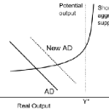](https://medium.com/the-quant-journey/effects-of-changes-in-oil-rents-and-broad-money-on-an-as-ad-model-from-1970-to-2007-4e5320e04c74?source=post_page-----67a3e0b11d17----1-------------------------------)

Andrea Chello

[Andrea Chello](https://medium.com/@chelloandrea?source=post_page-----67a3e0b11d17----2-------------------------------)

[·4 days ago](https://medium.com/the-quant-journey/the-global-financial-crisis-of-2008-regulations-explained-computationally-a2b30beb9ffb?source=post_page-----67a3e0b11d17----2-------------------------------)

## [The Global Financial Crisis of 2008: Regulations Explained Computationally](https://medium.com/the-quant-journey/the-global-financial-crisis-of-2008-regulations-explained-computationally-a2b30beb9ffb?source=post_page-----67a3e0b11d17----2-------------------------------)

[Finance](https://medium.com/tag/finance?source=post_page-----67a3e0b11d17---------------finance--------------------)

[15 min read](https://medium.com/the-quant-journey/the-global-financial-crisis-of-2008-regulations-explained-computationally-a2b30beb9ffb?source=post_page-----67a3e0b11d17----2-------------------------------)

[](https://medium.com/the-quant-journey/the-global-financial-crisis-of-2008-regulations-explained-computationally-a2b30beb9ffb?source=post_page-----67a3e0b11d17----2-------------------------------)

Andrea Chello

[Andrea Chello](https://medium.com/@chelloandrea?source=post_page-----67a3e0b11d17----3-------------------------------)

[·4 days ago](https://medium.com/the-quant-journey/hedge-fund-failures-an-computational-analysis-of-the-sources-of-risk-4f63457d056?source=post_page-----67a3e0b11d17----3-------------------------------)

## [Hedge Fund Failures: A Computational Analysis of the Sources of Risk](https://medium.com/the-quant-journey/hedge-fund-failures-an-computational-analysis-of-the-sources-of-risk-4f63457d056?source=post_page-----67a3e0b11d17----3-------------------------------)

[Finance](https://medium.com/tag/finance?source=post_page-----67a3e0b11d17---------------finance--------------------)

[13 min read](https://medium.com/the-quant-journey/hedge-fund-failures-an-computational-analysis-of-the-sources-of-risk-4f63457d056?source=post_page-----67a3e0b11d17----3-------------------------------)

[](https://medium.com/the-quant-journey/hedge-fund-failures-an-computational-analysis-of-the-sources-of-risk-4f63457d056?source=post_page-----67a3e0b11d17----3-------------------------------)

Andrea Chello

[Andrea Chello](https://medium.com/@chelloandrea?source=post_page-----67a3e0b11d17----4-------------------------------)

[·6 days ago](https://medium.com/the-quant-journey/stock-distribution-analysis-in-python-749badace6bd?source=post_page-----67a3e0b11d17----4-------------------------------)

## [Stock Distribution Analysis in Python](https://medium.com/the-quant-journey/stock-distribution-analysis-in-python-749badace6bd?source=post_page-----67a3e0b11d17----4-------------------------------)

[Python](https://medium.com/tag/python?source=post_page-----67a3e0b11d17---------------python--------------------)

[5 min read](https://medium.com/the-quant-journey/stock-distribution-analysis-in-python-749badace6bd?source=post_page-----67a3e0b11d17----4-------------------------------)

[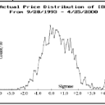](https://medium.com/the-quant-journey/stock-distribution-analysis-in-python-749badace6bd?source=post_page-----67a3e0b11d17----4-------------------------------)

[Read more from The Quant Journey](https://medium.com/the-quant-journey?source=post_page-----67a3e0b11d17-----------------------------------)

You can now subscribe to get stories delivered directly to your inbox.

**Got it**